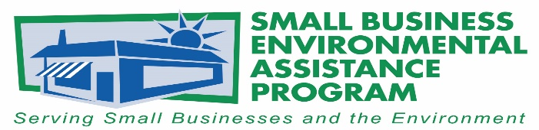

FOR IMMEDIATE RELEASE: September 26, 2019
Contact:
Lisa Ashenbrenner-Hunt
SBEAP National Steering Committee Chair
WI Small Business Environmental Assistance Program
Phone: (608) 266-6887
Email: lisa.ashenbrennerhunt@wisconsin.gov
Brunson Marine Group selected for the Small Business Environmental Stewardship Award
The National Steering Committee (NSC) of Small Business Environmental Assistance Programs (SBEAPs) & Small Business Ombudsmen (SBO) have recognized Brunson Marine Group with the 2019 Small Business Environmental Stewardship Award. The company, based in Wilson, North Carolina, was recognized for its accomplishments in the areas of improving environmental performance, pollution prevention, and sustainability.
Brunson Marine Group was recognized for partnering with the NC SBEAP on regulatory relief from onerous permit conditions. The company was able to drop from a Title V permit to a synthetic minor and obtain a waiver from the US Environmental Protection Agency’s Once-In Always-In policy since their emissions were well below 10 tons per year of styrene. These actions have substantially reduced their regulatory burden and fees, while maintaining a minimal impact on the environment.
The North Carolina Department of Environmental Quality’s Small Business Ombudsman, Tony Pendola, noted that, “Mr. Brunson, like so many other small businesses, did not know what specific regulatory relief might be available to him, so he simply asked for help.”
Mr. Brunson claimed; “We are proud to have been selected for this award, and it is due to many long hours of work to make sure our manufacturing facility protects our workers and the citizens of Wilson from any possible harm. Brunson Marine Group is proud to be good steward of our environment.”

“Small businesses face many challenges in today’s business climate, so the NSC is pleased to be able to recognize Brunson Marine Group for their efforts going above and beyond in their environmental performance. The SBEAPs are in place across the country to support small businesses; Brunson Marine Group is a strong example of the value that can come from a small business working closely with its state SBEAP” said Lisa Ashenbrenner Hunt, SBEAP/SBO NSC Chair.
The SBEAP/SBO NSC Awards are the States’ premier awards program for recognizing outstanding environmental leadership among small businesses and small business assistance providers. These awards recognize small businesses, SBEAP/SBO programs and individuals, trade associations and other business assistance providers who have made significant contributions to protecting the environment. The awards program is sponsored by the SBEAP/SBO NSC in partnership with U.S. EPA Asbestos and Small Business Office.
The NSC Awards were presented at the 2019 Annual SBEAP/SBO Training in Chicago, IL, May 15, 2019.
More information about the state SBEAP/SBO is available at https://nationalsbeap.org/ .
###

About the Small Business Environmental Assistance Programs and Small Business Ombudsmen
The Small Business Environmental Assistance Programs (SBEAP) and Small Business Ombudsmen (SBO) were created under Section 507 of the Clean Air Act Amendments of 1990. For more than 25 years, the SBEAP/SBO have provided extensive, hands-on technical assistance to small businesses across the country to help them understand and comply with complex environmental regulations. The SBEAP/SBO website, https://nationalsbeap.org/, is a resource for program participants and small businesses. Find your state specific contact at: https://nationalsbeap.org/states

