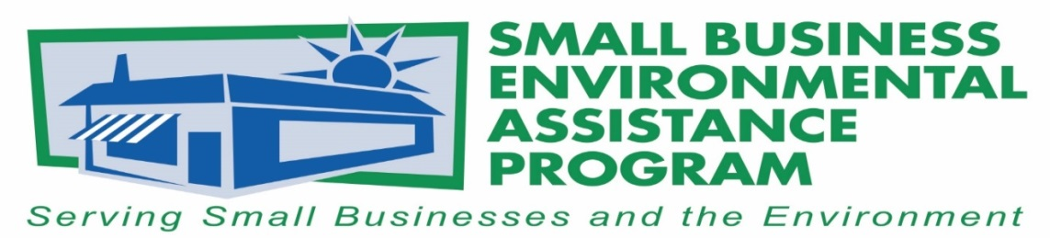

FOR IMMEDIATE RELEASE: May 18, 2017
Contact:
Tony Pendola
SBEAP/SBO National Steering Committee Chair
NC Department of Environmental Quality
Phone: (919) 707-8112
Email: Tony.Pendola@ncdenr.gov
California Air Resource Board official honored with National
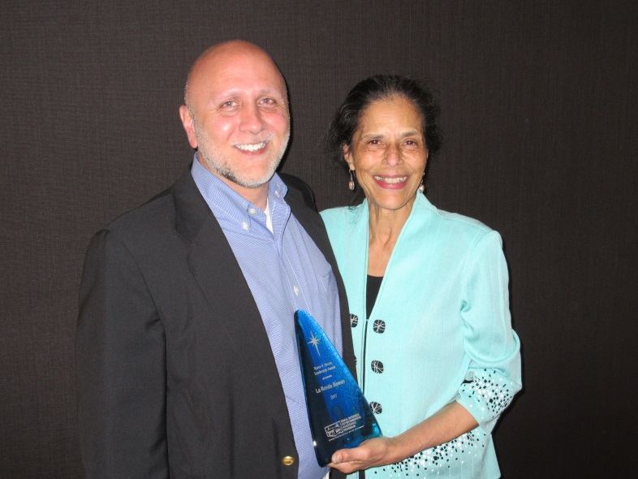
Karen V. Brown Leadership Award
Tony Pendola, NSC Chair and La Ronda Bowen, CARB SBO

The National Steering Committee ( NSC) for the nationwide Small Business Environmental Assistance Programs (r SBEAP), which were established by the 1990 amendments to the Clean Air Act, recognized La Ronda Bowen of the California Air Resources Board, ( CARB), as the 2017 winner of the Karen V. Brown Leadership Award at its May 2017 annual training in Denver, CO. Established to honor Brown’s leadership, innovation, dedication to environmental protection, and high standards this award is the highest honor a state SBEAP can receive from the NSC. Bowen was chosen by her peers on the NSC to receive the award for her accomplishments in small business environmental compliance, sustainability, advocacy, collaboration and assistance programs over the past 25 years. Bowen’s mantra, “making sure there is a place in the policy discussions for the voice of small business owners,” exemplifies her mindset
Bowen’s experience bridging the gap between air pollution regulators and small business owners includes establishing and directing the first SBEAP at the South Coast Air Quality Management District, in Southern CA (1989-2000), serving as the first mentor to other states under a “10 State Grant” pilot program established by Karen V. Brown. Texas, Wyoming, Colorado, and Utah, among others, used it to develop their own state SBEAP programs. As one of the first state SBEAP’s, Bowen was instrumental in the foundational work which established the National Steering Committee, the subcommittee structure, and a culture of collaboration and mentoring.
Bowen considers the confidentiality policy by Steve Herman, EPA’s former Assistant Administrator for Enforcement, the most important tool for small business owners that the SBEAP’s negotiated successfully. The policy removes a key barrier to compliance – fear on the part of small business owners that asking a question can lead to costly consequences. The confidentiality policy allows the small business owner an opportunity to figure out what compliance will cost in time and money, what resources are available to assist, and to understand the time, reputation, and financial costs associated with non-compliance. Bowen led the SBEAP effort on confidentiality.
Ms. Bowen returned to private practice in 2000. In 2009, CA Governor Arnold Schwarzenegger appointed Ms. Bowen as the CARB Ombudsman. Governor Jerry Brown reappointed her in 2012; in both instances, at the recommendation of CARB Board Chair, Mary D. Nichols.
Under Bowen’s influence, CARB has increased its awareness of the role of California small businesses as innovators, policy implementers, and partners in the state’s quest for an economically robust, low carbon economy and air that is healthy to breathe. Bowen initiated the Small Business Opportunity Advisory Panel ( SBOAP), consisting of regulated small business owners, the Executive Director of the state association of 35 air district executives, and the CARB Ombudsman. The SBOAP has influenced CARB’s climate policy, enforcement policy, and outreach, compliance assistance and engagement strategies.
“La Ronda has shown leadership by initiating a dialog among stakeholders in an attempt to enable them to resolve their differences and present government with a proposal that improves air quality and public health, without inhibiting economic growth in communities that can least afford it,” Bill La Marr, executive director of the California Small Business Alliance, said.
The NSC Awards are the states’ premier environmental awards for recognizing outstanding environmental performance, small businesses, trade associations, state programs and individuals that support the small business community. These award winners have made significant contributions to protecting the environment.
The NSC would also like to recognize Rivanna Natural Designs for its creative awards and continued support of green manufacturing. For more information on Rivanna Natural Designs, please visit www.rivannadesigns.com.
More information about SBEAPS is available at https://nationalsbeap.org/ .
###

About the Small Business Environmental Assistance Programs (SBEAPs)
Small Business Environmental Assistance Programs were created under Section 507 of the Clean Air Act Amendments of 1990. For more than 30 years, SBEAPs have provided extensive, hands-on technical assistance to small businesses across the country to help them understand and comply with complex environmental regulations. SBEAPs recently launched a new website, https://nationalsbeap.org/, which is a resource for program participants and small businesses. Find state-specific contacts at https://nationalsbeap.org/states
*Historical note: Although CA established the first SBEAP and served as the mentor to Texas to help it establish a program, Texas filed its State Implementation Plan (SIP) ahead of CA , making the Texas SBEAP the first filed with USEPA by date.
Word count: 531

