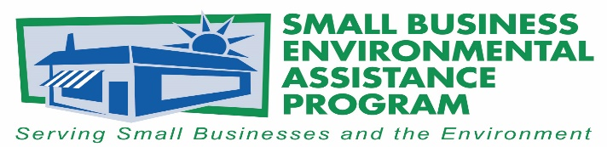

FOR IMMEDIATE RELEASE: May 29, 2018
Contact:
Lisa Ashenbrenner Hunt
SBEAP National Steering Committee Chair
WI Small Business Environmental Assistance Program
Phone: (608) 266-6887
Email: lisa.ashenbrennerhunt@wisconsin.gov
New Hampshire Receives 2018 Small Business Environmental Assistance Program Excellence Award
The National Steering Committee (NSC) of Small Business Environmental Assistance Programs (SBEAPs) & Small Business Ombudsmen (SBO) selected Sara Johnson of the New Hampshire Small Business Technical Assistance Program to receive the 2018 Small Business Environmental Assistance Program Award for Excellence. This award category recognizes exemplary performance of one SBEAP/SBO or individual in the areas of compliance assistance, sustainability, advocacy, and collaboration at the national level. The SBEAP Excellence Award emphasizes state program or individual leadership where they have created resources and work products, promoted policy advancements, developed program innovations, and established new partnerships to build a strong network of small business assistance.
Johnson was nominated by her peers and chosen by the SBEAP/SBO NSC for her leadership and outstanding efforts as Chair and Vice-chair of the NSC, for participating and providing leadership on different subcommittees for the NSC, providing important regulatory updates to fellow SBEAP/SBO, taking the lead on communications with partners such as the US Environmental Protection Agency (EPA), the US Small Business Administration, trade associations, promoting/encouraging use of social media to SBEAP/SBO to expand the reach of available compliance assistance resources, among others.
“Sara takes her small business environmental assistance program duties seriously and provides a valuable service to both the department and to the small business community. In addition to her duties as SBTAP Manager and SBO, she serves on the NHDES Lean Team, has participated in a Balanced Scorecard pilot, has co-chaired the department’s Compliance Assurance and Assistance Initiative, and has represented NHDES on the Governor’s Commission on Innovation, Efficiency and Transparency. Sara has a knack for bringing projects to completion and bringing teams to consensus,” commented Robert R. Scott, Commissioner, New Hampshire Department of Environmental Services.

“Sara Johnson serves as a tremendous advocate at both the national and state level for the small businesses she serves. Through her efforts to simplify compliance requirements and provide technical assistance, her program is ensuring New Hampshire small businesses understand complex regulations which is often one of the biggest challenges in achieving compliance,” said Lisa Ashenbrenner Hunt, Chair of the NSC of SBEAP/SBO.
The SBEAP/SBO NSC Awards are the States’ premier awards program for recognizing outstanding environmental leadership among small businesses and small business assistance providers. These awards recognize small businesses, SBEAP/SBO programs and individuals, trade associations and other business assistance providers who have made significant contributions to protecting the environment. The awards program is sponsored by the SBEAP/SBO NSC in partnership with U.S. EPA Asbestos and Small Business Office.

The NSC Awards were presented at the 2018 Annual SBEAP Training in the Washington, D.C. area in conjunction with National Small Business Week, May 1-3, 2016.
The NSC would also like to recognize Rivanna Natural Designs for their creative awards and their continued support of green manufacturing. For more information on Rivanna Natural Designs please visit www.rivannadesigns.com.

More information about the state SBEAP/SBO is available at https://nationalsbeap.org/ .
###

About the Small Business Environmental Assistance Programs and Small Business Ombudsmen
The Small Business Environmental Assistance Programs (SBEAP) and Small Business Ombudsmen (SBO) were created under Section 507 of the Clean Air Act Amendments of 1990. For more than 25 years, the SBEAP/SBO have provided extensive, hands-on technical assistance to small businesses across the country to help them understand and comply with complex environmental regulations. The SBEAP/SBO website, https://nationalsbeap.org/, is a resource for program participants and small businesses. Find your state specific contact at: https://nationalsbeap.org/states

