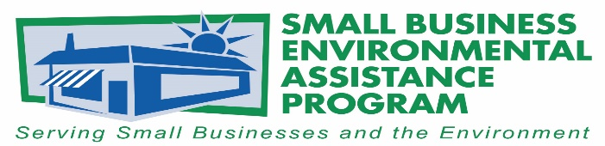

FOR IMMEDIATE RELEASE: July 2020
Contact: Nancy Larson
nlarson@ksu.edu

Neville Welding selected for the Small Business Environmental Stewardship Award
The National Steering Committee (NSC) of the Small Business Environmental Assistance Programs (SBEAPs) and Small Business Ombudsmen (SBO) have recognized Neville Welding Inc. with the 2020 Small Business Environmental Stewardship Award. The company, based in Kingman, Kansas, was recognized for its accomplishments in the areas of improving environmental performance, pollution prevention and sustainability.
“Neville contacted us for assistance in evaluating its air-permitting requirements and went beyond compliance to implement actions to reduce emissions to the environment,” said Nancy Larson, director with the K-State Pollution Prevention Institute and Kansas SBEAP.
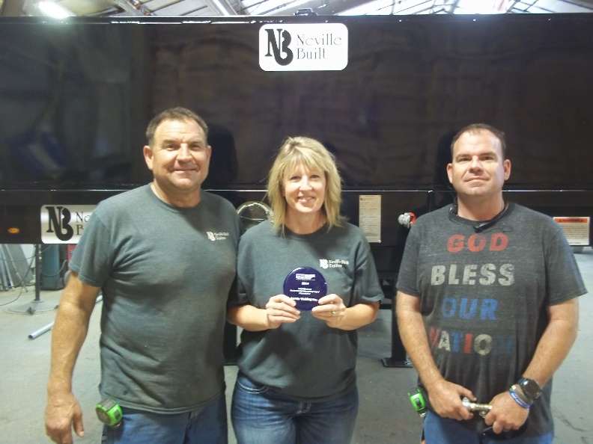
Neville Welding was recognized for working with the Kansas SBEAP on air and hazardous waste compliance and for implementing recommendations that included replacing its solvent with a substitute solvent that reduced the company’s volatile organic compound and hazardous air pollutants. In addition to reducing toxic emissions, Neville replaced more than 15 halogen lamps with LED light fixtures and repaired compressed-air hose leaks resulting in reduced energy use and cost.
Jill Neville, secretary and treasurer of Neville Welding, said, “Since 2018 we have shared/recommended with other manufacturers and business associates the positive benefits that SBEAP offers.”
Marvin Neville, President (right); Jill Neville, Secretary/Treasurer (center, holding award); Dennis Neville, Vice President (left)
The SBEAP/SBO NSC Awards are the states’ premier awards program for recognizing outstanding environmental leadership among small businesses and small business assistance providers. These awards recognize small businesses, SBEAP/SBO programs and individuals, trade associations and other business assistance providers who have made significant contributions to protecting the environment. The program is sponsored by the SBEAP/SBO NSC in partnership with the U.S. EPA Asbestos and Small Business Office.
More information about the state SBEAP/SBO is available at https://nationalsbeap.org/ .
###

About the Small Business Environmental Assistance Programs and Small Business Ombudsmen
The Small Business Environmental Assistance Programs (SBEAP) and Small Business Ombudsmen (SBO) were created under Section 507 of the Clean Air Act Amendments of 1990. For more than 25 years the SBEAP/SBO have provided extensive hands-on technical assistance to small businesses across the country to help them understand and comply with complex environmental regulations. The SBEAP/SBO website, https://nationalsbeap.org/, is a resource for program participants and small businesses. Find your state-specific contact at https://nationalsbeap.org/states.

