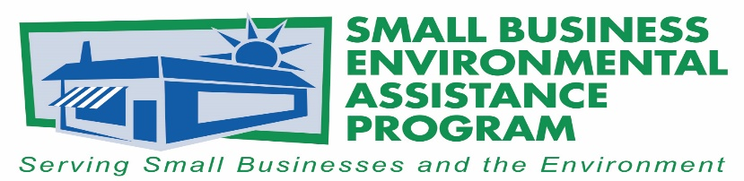
FOR IMMEDIATE RELEASE: May 18, 2017
Contact:
Tony Pendola
SBEAP/SBO National Steering Committee Chair
NC Department of Environmental Quality
Phone: (919) 707-8112
Email: Tony.Pendola@ncdenr.gov
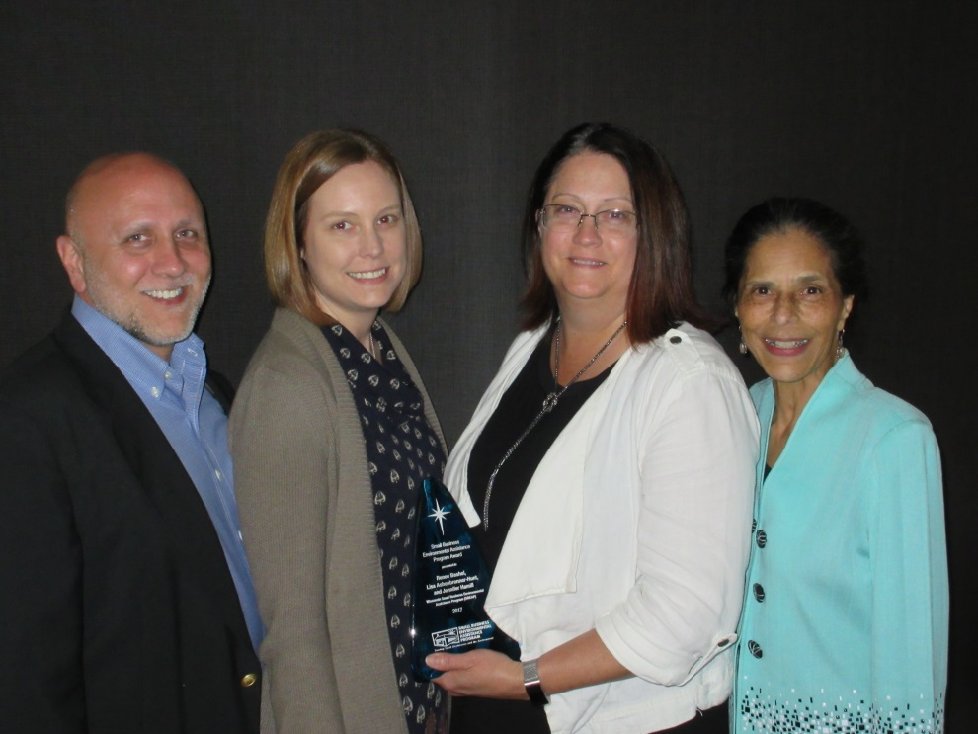
Wisconsin Receives 2017 National Small Business Environmental Assistance Program Award
Tony Pendola, NSC Chair, Lisa Ashenbrenner-Hunt, WI SBEAP, Renee Bashel, WI SBEAP and La Ronda Bowen, CARB

The National Steering Committee, or NSC, of the Small Business Environmental Assistance Programs and Small Business Ombudsmen, or SBEAP/SBO, recognized the Wisconsin Small Business Environmental Assistance Program, or WI SBEAP, through the 2017 National Small Business Environmental Assistance Program Award. This award honors its accomplishments in environmental compliance assistance, sustainability, advocacy for small businesses and collaboration efforts at the national level. The WI SBEAP was nominated by its peers and chosen by the NSC. The award was presented at the SBEAP/SBO annual conference May 16-18, 2017, in Denver, Colorado.
“The Wisconsin Small Business Environmental Assistance Program serves as a tremendous advocate at both the national and state level for the small businesses they serve. Through its efforts to simplify compliance requirements and provide technical assistance, the program is ensuring Wisconsin small businesses know how to comply with complex regulations, which is often one of the biggest challenges for them to overcome in achieving compliance,” said Tony Pendola, NSC chair for the SBEAP/SBO.
"The Wisconsin Small Business Environmental Assistance Program is honored to be selected by our state counterparts for the 2017 Small Business Environmental Assistance Program Award.
Like the small businesses we serve, the professionals in these programs are some of the most innovative and efficient problem solvers in government. Through partnerships with our agency’s regulatory programs and the business community, the Wisconsin program is proud of its efforts to bridge the communication gap to help ensure Wisconsin small business owners have the resources they need to grow their business, while at the same time achieving compliance and protecting the environment," said Renee Lesjak Bashel, coordinator of the Wisconsin Department of Natural Resources’ SBEAP and former NSC chair.
Current and former WI SBEAP staffs have held leadership roles at the regional and national level for the SBEAP/SBO and NSC. WI SBEAP was instrumental in development of the first national SBEAP/SBO logo, a national annual report template, a customer satisfaction survey and other data collection tools that state SBEAPs use to promote the value of their programs to small businesses. Also, the WI SBEAP led a regional grant project, the Autobody Environmental Results Program, to support outreach efforts about environmental requirements affecting 12,000 collision repairs shops in Wisconsin and surrounding states. In 2016, the WI SBEAP made more than 90,000 contacts to provide environmental assistance through its toll-free hotline, emails to DNRsmallbusiness@wisconsin.gov, presentations, conference exhibits, electronic newsletter and other online resources.
The SBEAP/SBO NSC Awards are the premier environmental awards program for recognizing states’ outstanding environmental performance, programs and individuals. The awards honor and recognize small businesses, individuals, trade associations and others who have made significant contributions to protecting the environment. Information on the awards is available at https://nationalsbeap.org/content/2017-awards.

More information about the WI SBEAP is available at http://dnr.wi.gov/topic/smallbusiness/.

The NSC would also like to recognize Rivanna Natural Designs for its creative awards and continued support of green manufacturing. For more information on Rivanna Natural Designs, please visit www.rivannadesigns.com.

More information about state Small Business Environmental Assistance Programs is available at https://nationalsbeap.org/ .
###

About Small Business Environmental Assistance Programs (SBEAPs)
Small Business Environmental Assistance Programs were created under Section 507 of the Clean Air Act Amendments of 1990. For more than 25 years, SBEAPs have provided extensive, hands-on technical assistance to small businesses across the country to help them understand and comply with complex environmental regulations. SBEAPs recently launched a new website, https://nationalsbeap.org/, which is a resource for program participants and small businesses. Find state-specific contacts at https://nationalsbeap.org/states

