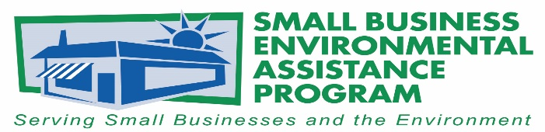

FOR IMMEDIATE RELEASE: June 28, 2018
Contact:
Lisa Ashenbrenner-Hunt
SBEAP National Steering Committee Chair
WI Small Business Environmental Assistance Program
Phone: (608) 266-6887
Email: lisa.ashenbrennerhunt@wisconsin.gov
Small Business Environmental Stewardship Award announcements
The National Steering Committee (NSC) of Small Business Environmental Assistance Programs (SBEAPs) & Small Business Ombudsmen (SBO) have recognized Great Divide Brewing Company as the 2018 winner of the Small Business Environmental Stewardship Award. The company, based in Denver, Colorado, was recognized for its accomplishments in the areas of improving environmental performance, pollution prevention, sustainability, and mentoring.
Great Divide Brewing Company was recognized for working with the Colorado SBEAP on the 2017 Sustainable Brewery Summit, developing an Environmental Management System which lead to changes in recycling or reuse of their materials or byproducts, reductions in environmental impacts, retrofitting operations with environmentally-friendly designs, and sharing what they learned about sustainable practices with other breweries at the Summit.
A ceremony was held June 14, 2018, at the Colorado Department of Public Health and Environment (CDPHE) in Denver, Colorado, where the award was presented by Martha Rudolph, Director of Environmental Programs for CDPHE, to Erin Cox, QA/QC Manager and Sustainability Coordinator at Great Divide Brewing Company. Ms. Cox said "It meant a lot to actually sit in a room with a lot of the folks from the state that have been key in Great Divide’s successes over the past year and a half. I can’t thank everyone enough!"
“Small businesses face many challenges in today’s business climate, so the NSC is pleased to be able to recognize Great Divide Brewing Company for their efforts going above and beyond in their environmental performance. The SBEAPs are in place across the country to support small businesses; Great Divide Brewing Company is a strong example of the value that can come from a small business working closely with its state SBEAP” said Lisa Ashenbrenner Hunt, SBEAP/SBO NSC Chair.
The SBEAP/SBO NSC Awards are the States’ premier awards program for recognizing outstanding environmental leadership among small businesses and small business assistance providers. These awards recognize small businesses, SBEAP/SBO programs and individuals, trade associations and other business assistance providers who have made significant contributions to protecting the environment. The awards program is sponsored by the SBEAP/SBO NSC in partnership with U.S. EPA Asbestos and Small Business Office.
The NSC Awards were presented at the 2018 Annual SBEAP Training in the Washington, D.C. area in conjunction with National Small Business Week, May 1-3, 2016.
The NSC would also like to recognize Rivanna Natural Designs for their creative awards and their continued support of green manufacturing. For more information on Rivanna Natural Designs please visit www.rivannadesigns.com.
More information about the state SBEAP/SBO is available at https://nationalsbeap.org/ .
###

About the Small Business Environmental Assistance Programs and Small Business Ombudsmen
The Small Business Environmental Assistance Programs (SBEAP) and Small Business Ombudsmen (SBO) were created under Section 507 of the Clean Air Act Amendments of 1990. For more than 25 years, the SBEAP/SBO have provided extensive, hands-on technical assistance to small businesses across the country to help them understand and comply with complex environmental regulations. The SBEAP/SBO website, https://nationalsbeap.org/, is a resource for program participants and small businesses. Find your state specific contact at: https://nationalsbeap.org/states

