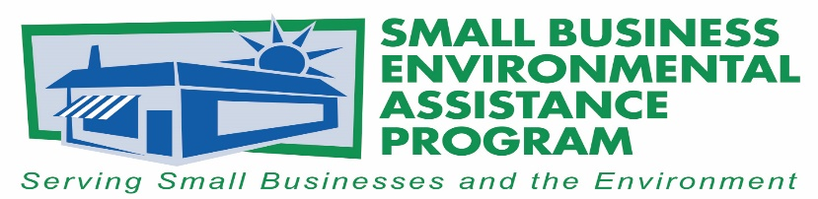
FOR IMMEDIATE RELEASE May 18, 2017

Contact:
Kelly Cofrancisco
Outreach and Partnership Manager, Pennsylvania SBDC
(215) 746-6474
kcofran@wharton.upenn.edu

Tony Pendola
SBEAP/SBO National Steering Committee Chair
(919) 707-8112
Tony.Pendola@ncdenr.gov
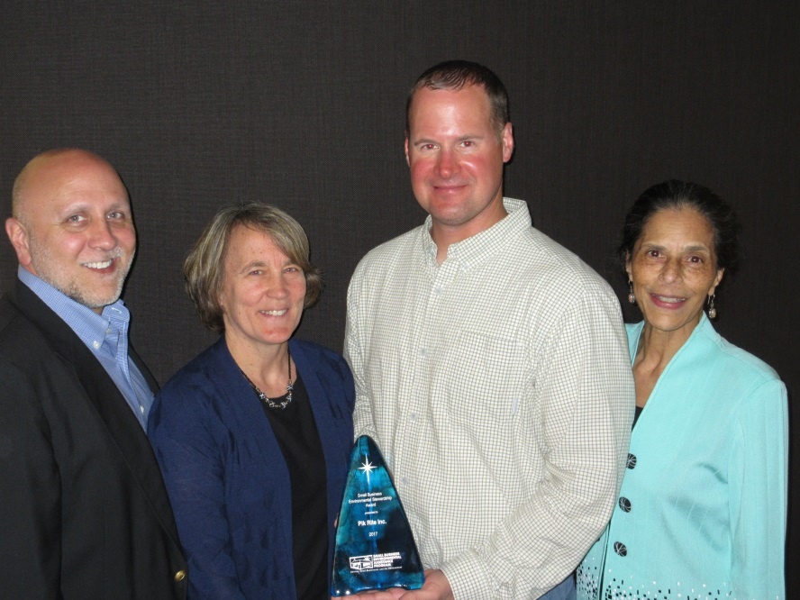
Pik Rite Inc. Receives 2017 National Small Business
Tony Pendola, NSC Chair, Nancy Crickman, PA SBDC, Jeremy Hancher, PA SBDC, and La Ronda Bowen, CA CARB
Environmental Stewardship Award

The National Small Business Environmental Assistance Programs (SBEAP) recognized Pik Rite, Inc. as the 2017 winner of its Small Business Environmental Stewardship Award. The company, based in Lewisburg, Pennsylvania was chosen by the SBEAP’s National Steering Committee. The award was presented on May 17th at the SBEAP/SBO annual conference held in Denver, Colorado.
Pik Rite, Inc. designs and manufactures innovative, quality-built vegetable harvesters, agricultural manure spreaders, commercial waste handling and specialized vacuum tanks, dump bodies and debris collectors. Pik Rite equipment is customized to meet the needs of many industries including farming, commercial waste hauling, gas drilling, construction, and municipal waste, and is used domestically and exported to 26 countries.
Nominated by the Pennsylvania Small Business Development Centers’ (SBDC) Environmental Management Assistance Program (EMAP), Pik Rite, Inc. was recognized for its accomplishments in the areas of environmental compliance, implementing energy efficiency and pollution prevention practices, bringing new innovative products to market, and for developing lean manufacturing practices.
“Pik Rite truly embodies what it means to be a successful small business and role model to others. Pik Rite’s activities have inspired other Pennsylvania small businesses to successfully achieve company growth while showing a true commitment to the environment. We are pleased to have provided assistance with environmental regulatory requirements, upgrading equipment to become more energy efficient, and sustainability initiatives as they have prospered and grown,” said Nancy Crickman, Director of Environmental, Energy, and Technology Services at the Pennsylvania SBDC.
The SBEAP’s National Steering Committee Awards are the country’s premier environmental awards for recognizing outstanding environmental performance, programs and individuals. The awards honor and recognize small businesses, individuals, trade associations and others who have made significant contributions to protecting the environment.
“We are very pleased to recognize Pik Rite for their many efforts in going above and beyond in their compliance with environmental requirements,” said Tony Pendola, SBEAP National Steering Committee Chair. “A manufacturer such as Pik Rite faces many challenges in today’s world. We are excited to hear that they found SBEAP resources in the Commonwealth of Pennsylvania prove to be very meaningful, resourceful, and dependable for the small business community.”
More information about the state Small Business Environmental Assistance Programs is available at https://nationalsbeap.org/.
###

About the Small Business Environmental Assistance Programs (SBEAPs)
The Small Business Environmental Assistance Programs were created under Section 507 of the Clean Air Act Amendments of 1990. For more than 25 years, the SBEAPs have provided extensive, hands-on technical assistance to small businesses across the country to help them understand and comply with complex environmental regulations. The SBEAPs recently launched a new website, https://nationalsbeap.org/which is a resource for program participants and small businesses. You can find your state specific contact at: https://nationalsbeap.org/states

About Pennsylvania Small Business Development Centers (SBDC)
The Pennsylvania SBDC network is the only statewide, nationally accredited program that provides high quality one-on-one consulting, training and information resources to empower new and existing businesses. SBDC consultants work with entrepreneurs in confidential, individualized sessions to help them with a range of business issues including testing a new business proposition, shaping a business plan, investigating funding opportunities, and much more. The SBDC program is a public/private partnership with the U.S. Small Business Administration, the Pennsylvania Department of Community and Economic Development and 18 universities and colleges across the Commonwealth. For more information on the Pennsylvania SBDC services and impact, please visit www.pasbdc.org.

