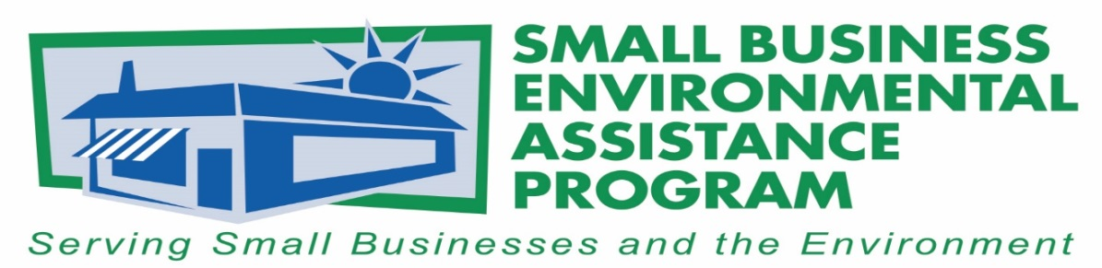

FOR IMMEDIATE RELEASE: May 18, 2017
Contact:
Tony Pendola
SBEAP/SBO National Steering Committee Chair
NC Department of Environmental Quality
Phone: (919) 707-8112
Email: Tony.Pendola@ncdenr.gov
North American Sustainable Refrigeration Council Receives 2017 National Small Business Trade Association Environmental Leadership Award
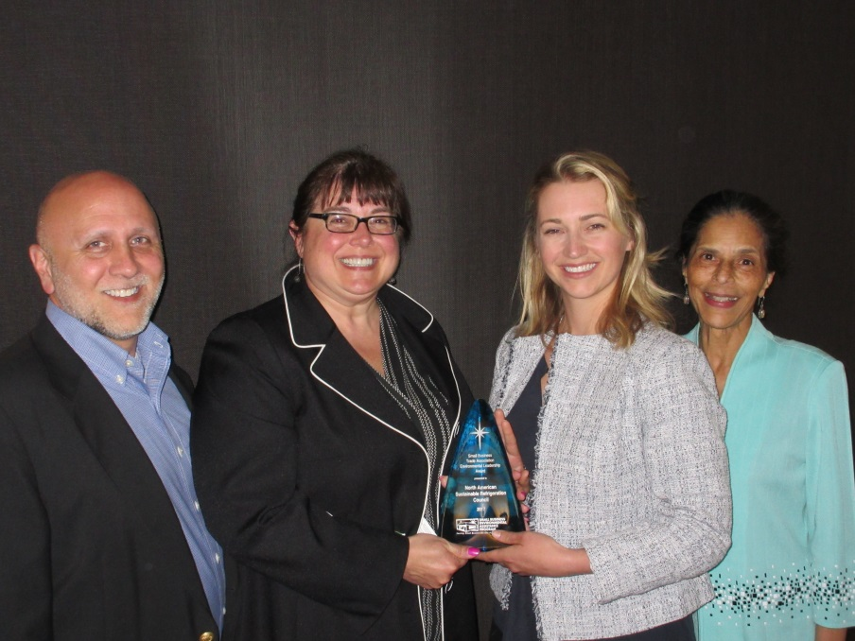
Tony Pendola, NSC Chair, Keilly Witman, NASRC, Danielle Wright, NASRC, and La Ronda Bowen, CARB SBO

The North American Sustainable Refrigeration Council, or NASRC, headquartered in Santa Cruz, California, was recognized by the National Steering Committee, or NSC, of Small Business Environmental Assistance Programs, or SBEAPs, and Small Business Ombudsmen, or SBO, for its leadership nationwide in the areas of compliance assistance, sustainability, advocacy and collaboration.

NASRC was awarded for its work in accelerating the transition from fluorinated gases — F-gases, including hydrofluorocarbons — to low-global warming potential, or GWP, refrigeration equipment and technologies. F-gases are the fastest-growing source of greenhouse gas emissions in California and globally.

NASRC is being recognized for establishing best practices for natural refrigerants such as low-charge hydrocarbon and ammonia, and carbon dioxide; providing educational resources to service providers, end users and manufacturers of natural refrigerants; and supporting certification organizations and government agencies to help streamline approval processes for natural refrigerant equipment and technologies.

NASRC’s collaboration with utilities such as the Sacramento Municipal Utility District and end users of refrigeration equipment has been instrumental in developing utility incentives that include an extra bonus for small businesses to encourage the conversion to natural refrigerant gases and energy efficiency equipment. Because refrigerant equipment has a high cost of ownership, it is imperative small businesses have incentives. This award underscores NASRC’s leadership in the industry, not only shining the spotlight on sustainable practices, but also for showcasing low-GWP alternatives and the importance of business/small business incentives, and the role of small businesses in this industry.

“It is a great honor to be selected for this award. NASRC has accomplished a tremendous amount given we have only been in existence for less than two years. There is still much work to be done to remove the barriers of adopting natural refrigerants, especially for small businesses that need financial incentives to support the transition. This award not only highlights the important role of natural refrigerants in significantly reducing greenhouse gas emissions but the collaboration necessary in order achieve our vision of a more sustainable future,” said Danielle Wright, executive director of NASRC.
NASRC member Source Refrigeration has also collaborated with the California Air Resources Board’s SBEAP in the production of a leak inspection video and fact sheet. NASRC has analyzed whether financial incentives could help promote more immediate transition for small- and medium-sized markets. In addition to this incentive program, it is helping to establish best practices for natural refrigerants, providing education resources and online training opportunities.
This award will be presented to NASRC at the NSC meeting May 17, 2017, 4:30-6 p.m., in Denver, Colorado.
The SBEAP/SBO NSC Awards are the premier environmental awards for recognizing outstanding environmental performance, programs and individuals. The awards honor and recognize small businesses, individuals, trade associations and others who have made significant contributions to protecting the environment.
The NSC would also like to recognize Rivanna Natural Designs for its creative awards and continued support of green manufacturing. For more information on Rivanna Natural Designs, please visit www.rivannadesigns.com. More information about SBEAPs is available at https://nationalsbeap.org/ .
###

About the Small Business Environmental Assistance Programs (SBEAPs)
The Small Business Environmental Assistance Programs were created under Section 507 of the Clean Air Act Amendments of 1990. For more than 25 years, the SBEAPs have provided extensive, hands-on technical assistance to small businesses across the country to help them understand and comply with complex environmental regulations. SBEAPs recently launched a new website, https://nationalsbeap.org/, which is a resource for program participants and small businesses. Find state-specific contacts at https://nationalsbeap.org/states

